Quick card



new CONCUR TRAVEL

# A screenshot of a login form Description automatically generatedLogin (check which datacenter is applicable)

1. US Datacenter: [www.concursolutions.com](http://www.concursolutions.com) or EU Datacenter: [www.eu1.concursolutions.com](http://www.eu1.concursolutions.com)
2. Enter your login credentials. Click “Forgot password” as a first-time user. Then you will be prompted to authenticate via 2FA.
3. The first time you login you may need to accept the User Data Privacy Agreement to enter the tool.
4. Click the Profile icon  located in the top right menu bar to update your profile.

# A screenshot of a computer Description automatically generatedManage Profile

1. A screenshot of a computer

   Description automatically generatedAfter first login update your profile.
2. Profile links are displayed under Profile Options.
3. Complete all mandatory fields (marked as required), this includes Form of Payment. All optional fields are helpful and may be used during the booking process.
4. 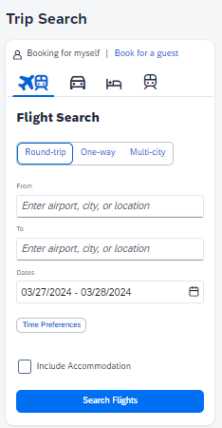Travel arrangers can be added here too.

# Search

1. After updating your profile, click the SAP Concur logo  to begin your travel search.
2. Choose Round Trip, One Way or Multi City.
3. Select Flight, Car, Hotel, Rail icons and complete enter your travel details.
4. Click Search.

# Book Flights & Rail

1. Results can be sorted, filtered using the **Sort By** option.
2. Sorting order and/or filters may be used to refine results.
3. Each tile will show fare summary. Click **Fare details** for additional information.
4. Click **Select Fare** to choose departure flight or rail and then you will be presented with return options.
5. Select seats and form of payment on the **Review and Book** page.

# Book Car and Hotel

1. 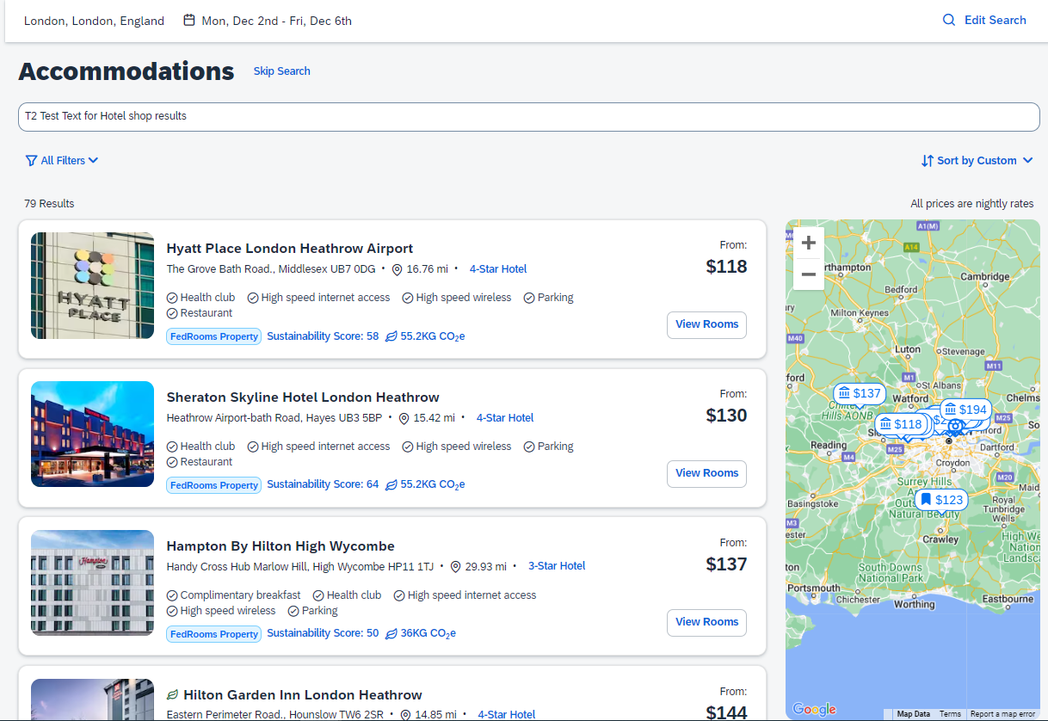For hotel, after entering search criteria results will display on a map and also in a list.
2. Sorting order and/or filters, such as company preferred hotels and sustainability options, are clearly labeled and may be used to refine results.
3. Click on **View Rooms** to see hotel room types and rates.
4. Policy icons identify in/out policy.
5. Hotel cancellation policy must be accepted on the **Review and Book** page.
6. For car, there are similar search options where selection can be made by car type with policy icon indicators and search abilities that include electric car.

# Confirm booking

1. The **Finalize** page provides an overview of segments chosen. Seats can be changed, fare rules can be reviewed, additional segments can be booked, etc.
2. A **Trip Confirmed** screen displays.
3. To view, change or cancel a trip, display the trip via the **Trip Library** or from the section **My Trips**.

